Zone 16 Pony Club camp regsitration instructions
Thankyou for working with us as we move camp enteries online, and learn how to get the best out of the new pony club event entry tools. Please also rememebr to volunteer to assist at camp, we need yourhelp to make this a great event for the children and to make sure we share the load across our volunteers. You don’t need to be horsey – we have roles/ activitites for everyone!
You will need to have a online Pony club profile to register for the event.
EACH RIDER MUST HAVE THEIR OWN LOGON AND REGISTER THROUGH THEIR INDIVUDUAL LOGON for details (ie name, age, club etc) to come across successfully.
ONLY CLICK ADDITIONAL info/Payments against 1 rider not both (including merchandise).
Your club will also need to process your membership renwal via this sytem, please talk to your club if any issues or concerns in the first instance

Go to:
https://osm-pony.omnisportsmanagement.com/OSMMain/(S(kyzzwkbe2h1z3rko2ei0tms3))/OSMMainNew.aspx

Click on the MEMBERS ICON
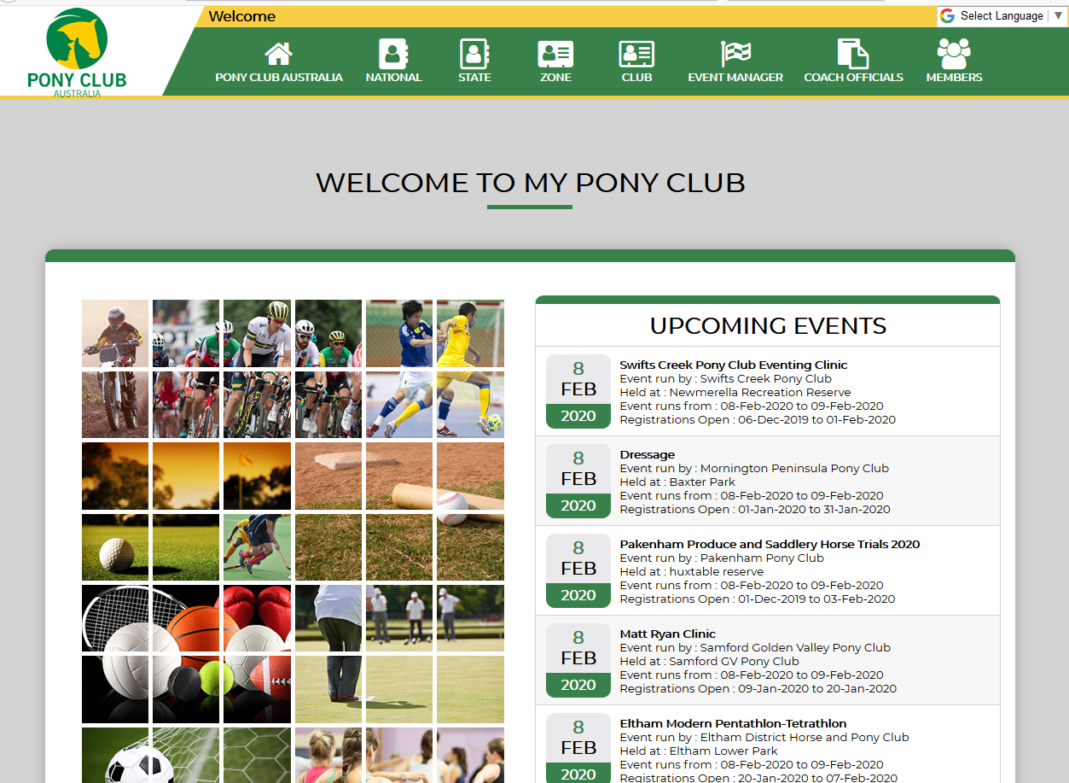
Follow the prompts to either set up your MYPONYCLUB profile or sign in with you current registration details. (If you have been a member of pony club previously and haven’t registered online and don’t know your Pony club ID number, contact your secretary as they should be able to obtain this for you).
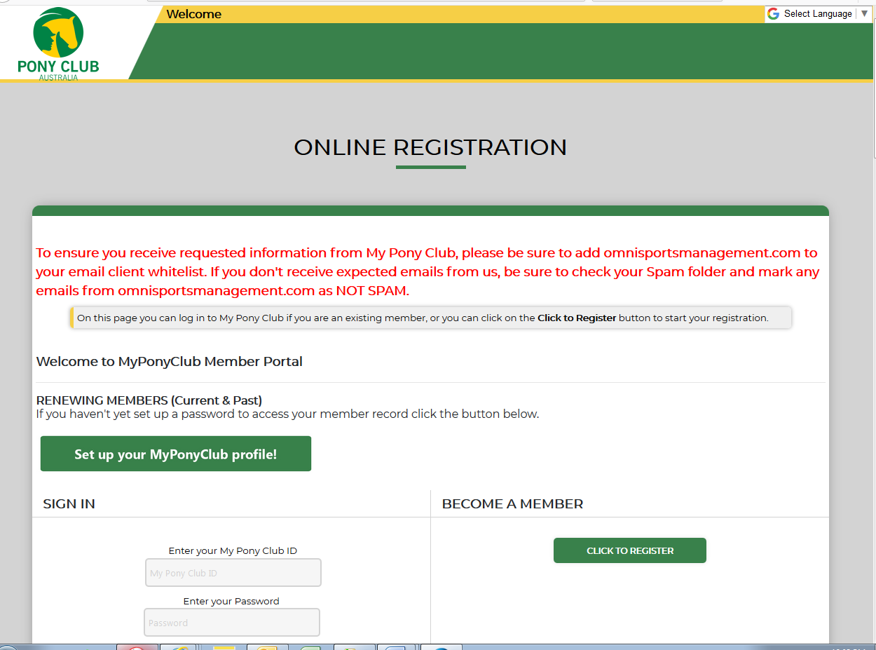
Once you have logged in click on the events icon and scroll down to Available option and click
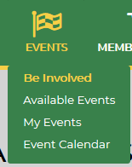
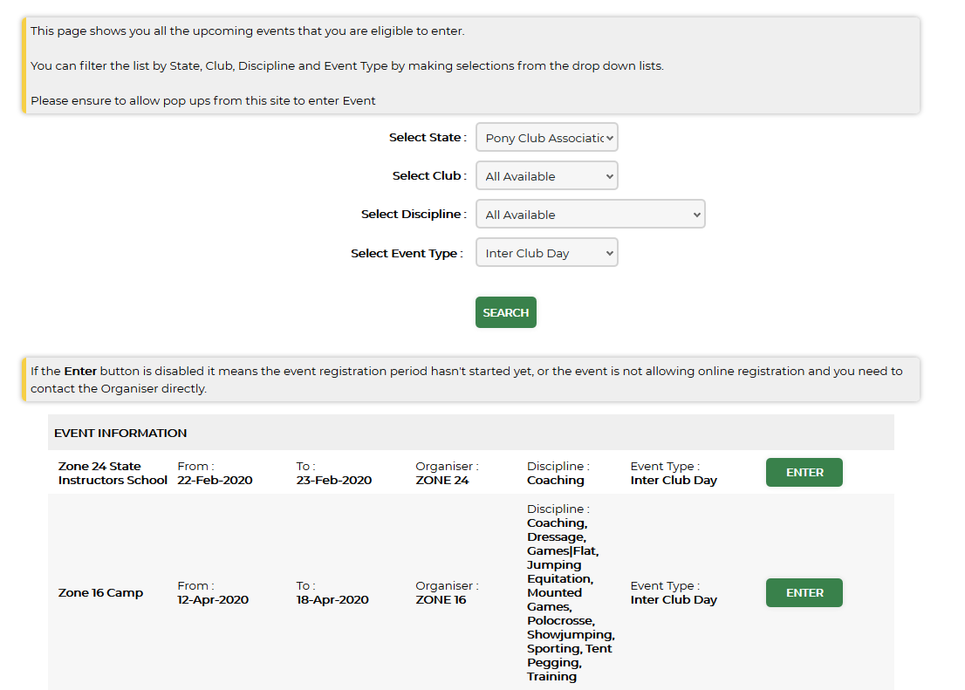
Select State: Select Pony Club Association of NSW
Select Event Type: Select Inter Club Day
Click enter on the Zone 16 Camp
This will take you to the event details page.
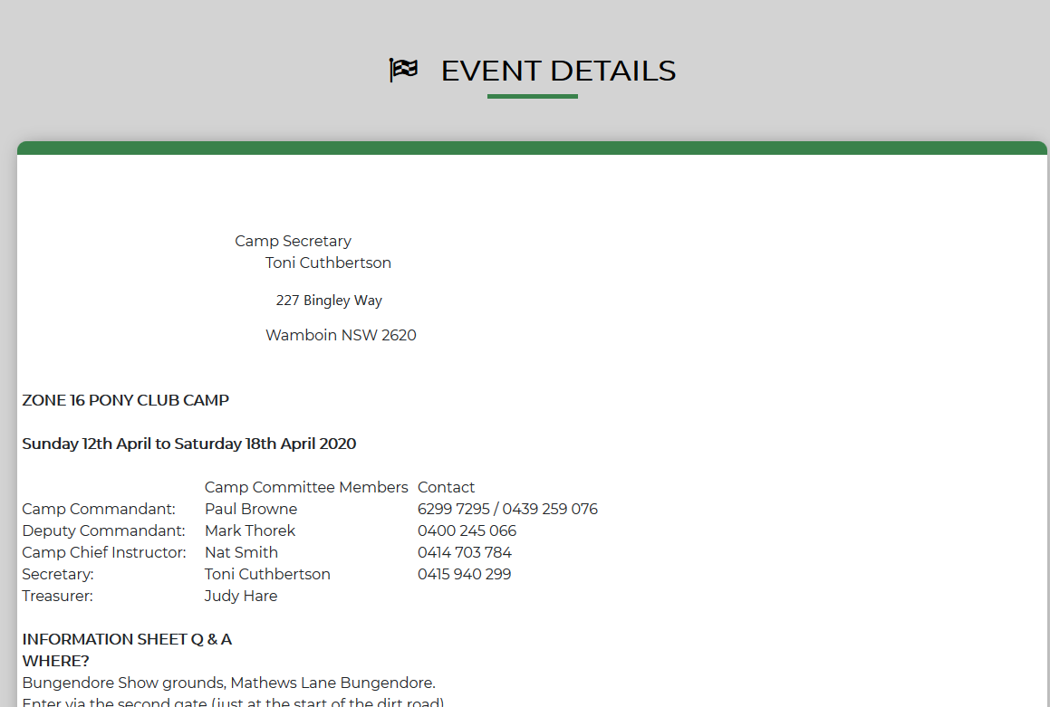
Select the classes from the list that appears that you want to enter into.
Note: If you have more than 1 rider, please make sure you register as first rider, second rider, third rider via each riders log in etc so the pricing is calculated correctly. If you have 4 riders please contact Toni 0415 940 299 , email zone16camp@gmail.com
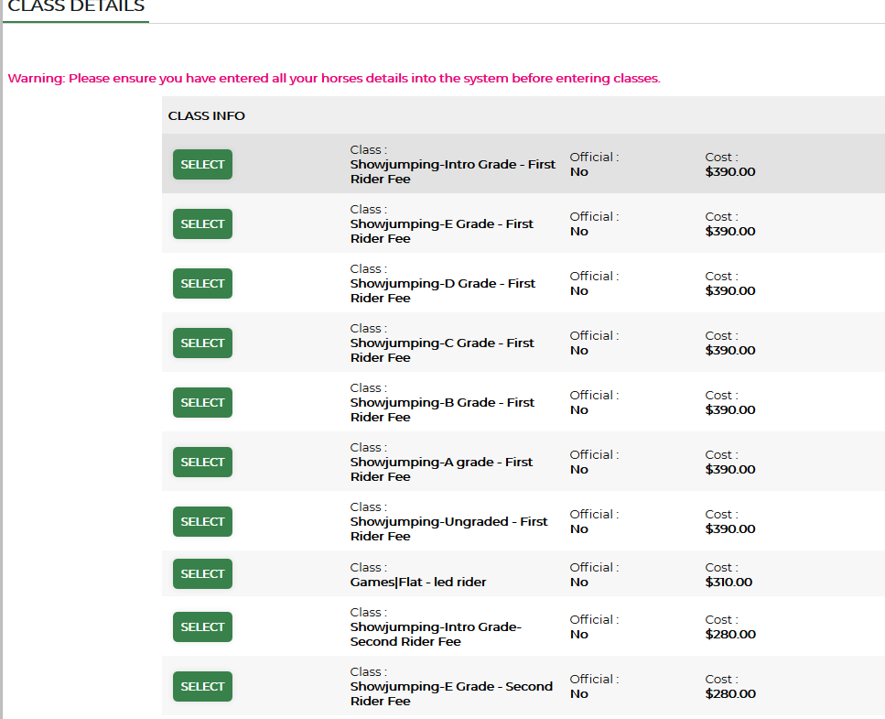
If you have not registered a horse in the system, when you select the class this pop up screen will appear. Click on 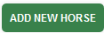
Complete the details and click save.
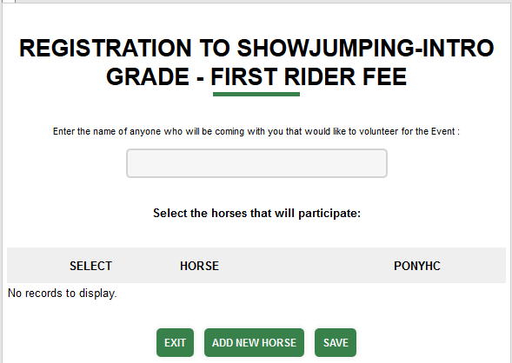
Once you have completed all the registrations click register at the bottom of the page
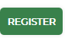
You must read and agree to this to continue
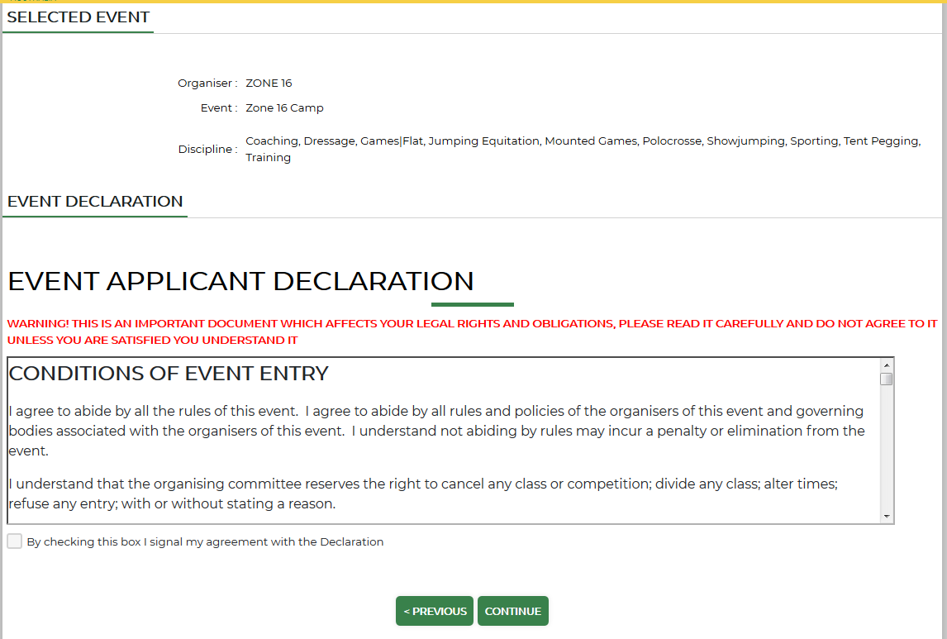
Click on any additional products you require – Remember it is 1 camp site per family not per club.
Don’t forget to add a weekly meal ticket - for non-riders at camp. Includes 3 meals, morning and afternoon tea and drinks per day. Special diets cannot be catered for.
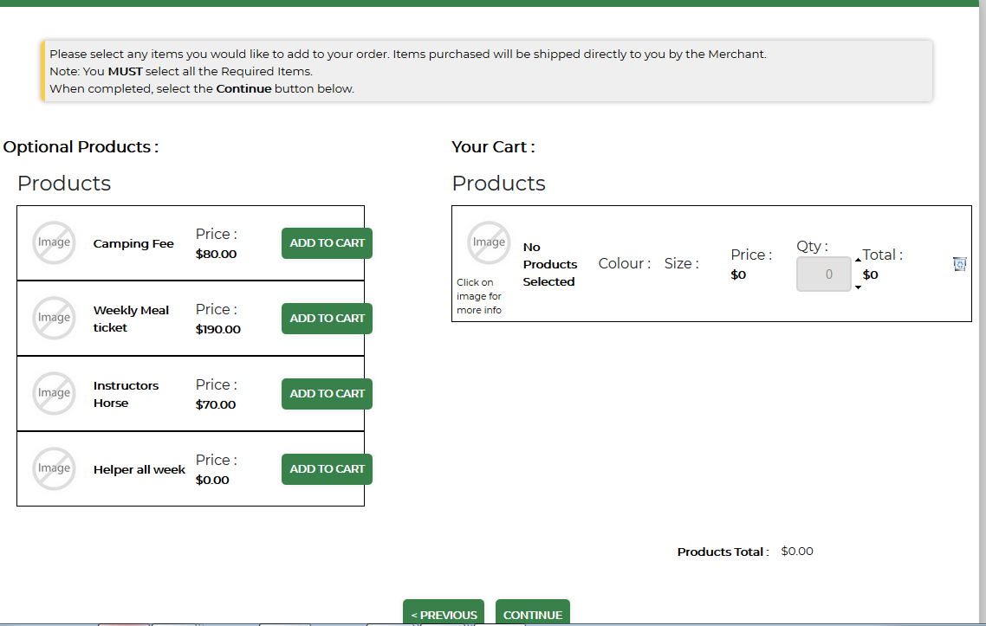
Complete all the event questions and details. 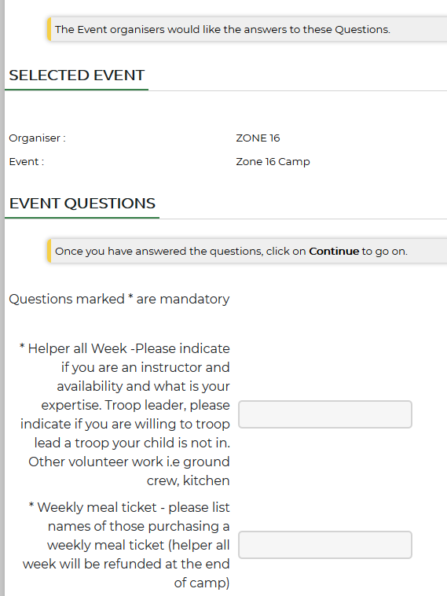

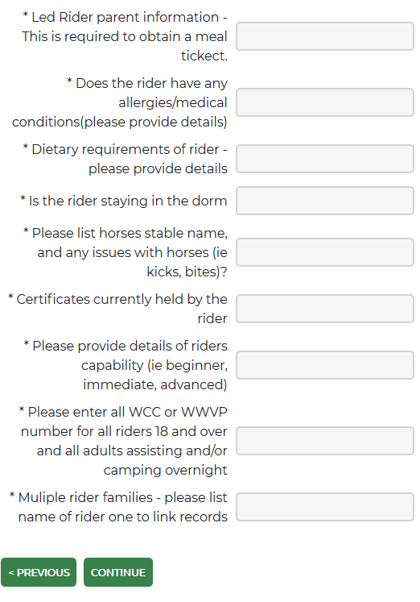
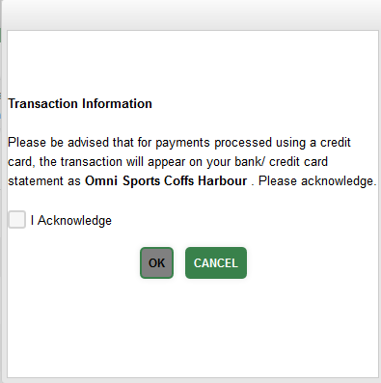
Click I Acknowledge and OK

Complete the payment details.

