Resumption of Club Rally Days Phase 1.
PCA NSW have confirmed with the Acting Minister of Sport and the Office of Sport that the easing of restrictions as announced by the Premier on the 10th May 2020 apply to sporting organisations for training purposes only and therefore we can confirm that clubs and zones may return to sport for training activities only whilst following the NSW Public Health Orders.
PCA NSW will continue to collaborate and strongly supports the work being done by the NSW Office of Sport during this time. Any further return to sport plan must be aligned to advice from health officials. We recognise that having the most active cases in the country our return to sport may not be as fast as other states. However, be assured that PCA NSW and the Office of Sport are working to finalise a time frames for each phase of return to sport and will keep members updated accordingly.

Members are reminded that the insurance brokers have extended Personal Accident coverage during restrictions as below:
It is hereby declared and agreed with effect from 31 March 2020 to 31 December 2020 the following amendments are noted:
Due to restrictions imposed in respect of the COVID-19 crisis, the operative time in respect of Pony Club Riding Members is amended to read as follows:

Pony Club Riding Members
(excluding Open Competition Riders and Day Members)
24 hours a day 7 days a week in respect of all hazards which a member is exposed to whilst a member is engaged in non-income earning activities involving riding, caring for or handling horses or ponies, and travel to and from events, which are run by the insured.

This amendment will remain in force until such time as State and Federal government restrictions in respect of gatherings of multiple persons are lifted, at which time the operative time will revert to that in place prior to this Endorsement.

Members are reminded that they must comply with PCA NSW, NSW Health Guidelines, NSW Public Health Orders, complete COVID-19 declaration forms and follow all directions from PCA NSW officials at all levels in order to ensure that might compromise a members position in the event of a claim.

PCA NSW are very mindful that we do not want our sport and any club or area to become the next COVID-19 cluster and want to ensure the health and well-being of all our members. PCA NSW recommends the following phased resumption of sport to commence on the 22nd May 2020.
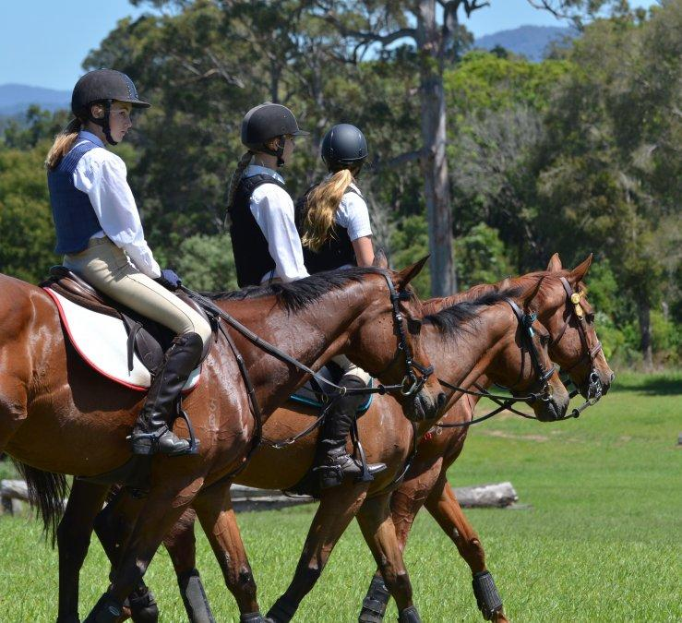
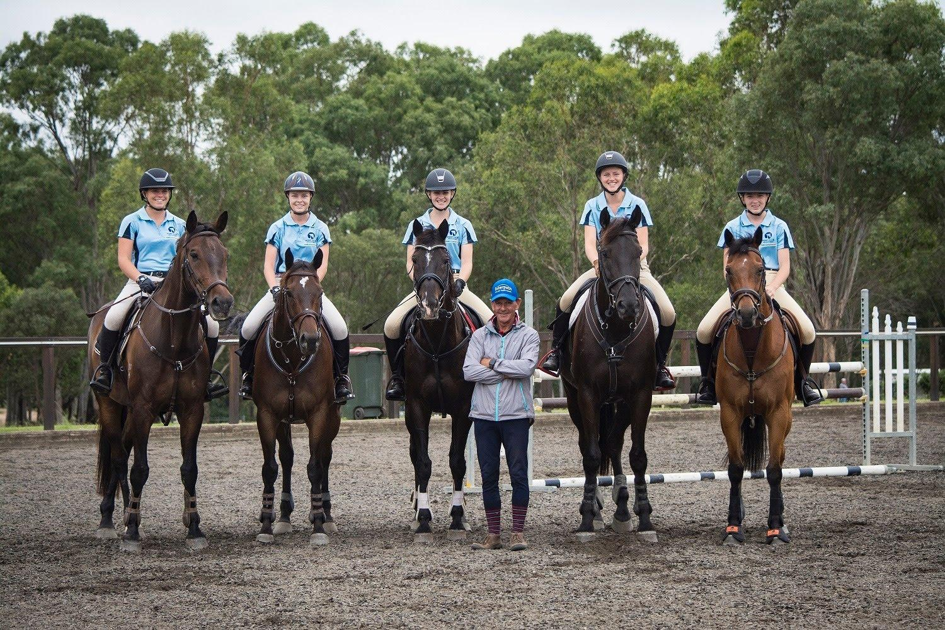
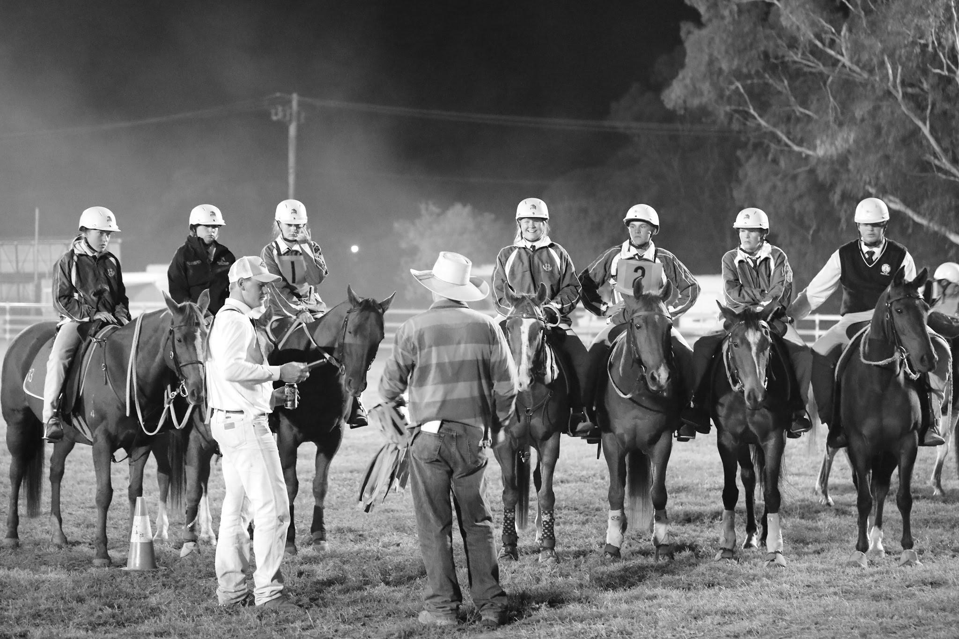

Initially – Phase 1:
Riders will be limited or must be scheduled to be adhere to the outdoor gathering guidelines of only 10 people at any one time
Extra bio-security procedures will need to be put in place by clubs
All NSW Public Health Orders will need to be adhered to including social distancing and hygiene practices

Next step – Phase 2:
Dates to be confirmed but will be in line with NSW Public Health Orders (possibly 4 weeks)
Rider numbers will be increased but will still be limited in line with the NSW guidelines
Extra bio-security procedures will need to continue with clubs providing PPE
All NSW Public Health Orders will need to be adhered to including social distancing and good hygiene practices

Back to normal – Phase 3
Dates to be confirmed but will be in line with NSW Public Health Orders (possibly 4 weeks after completion of phase 2):
Riders numbers will return to pre-Covid-19 numbers
Extra bio-security procedures will need to continue with clubs providing PPE
NSW Public Health Order will need to be adhered to including social distancing and good hygiene practices

Club Rally Days Phase 1 commencing 22 May 2020.
Date of Event: 28th June 2020 | Risk Management Team for Murrumbateman Pony Club is made up of the following members:  Club Senior Instructor – Heather Coutts  President and Safety Officer – Rob McLachlan  Secretary and MPIO – Cait Greenup

Risk | Risk Rating | Control / Actions | Person Responsible
Attendees to confirm and sign Covid-19 declaration which states that they are well and have not had contact with anyone with COVID-19 | 1 | If rider and/or family members have been to Covid-19 affected areas, or been in contact with someone who has Covid-19 or shows symptoms of Covid-19 they may not attend and need to self-isolate for 14 days and unable to attend pony club until signed off by Doctor with a negative Covid-19 test result. | Self-monitoring and if necessary self-isolate– members must determine their own level of risk depending and their current health status
Contracting Covid-19 during travel to event – driving | 4 | Ensure that riders follow all guidelines produced by NSW Health on how to protect yourself – see NSW Health website and recommendations below. | Self-monitoring – members must determine their own level of risk depending and their current health status
Contracting Covid-19 – whilst at Pony Club | 4 | - PCA NSW have strict bio-security protocols in place for both riders and horses.  - All participants and support person/s attending grounds MUST complete Covid-19 declaration form and submit upon arrival – if participant and support person/s do not complete a form they must be asked to leave the grounds.  - Riders to follow all directions of Organising Committee  - Organising Committee will ensure that the venue where appropriate has been cleaned prior to commencement and maintained during the event  - Organising Committee to provide 60% alcohol based hand sanitizer  - Rider and other attendees to regularly wash hands/use hand sanitizer and social distance as per NSW Health regulations  - Riders and other attendees to follow all guidelines produced by NSW Heath on how to protect yourself – see below  - Minimal equipment will be used and will be handled by dedicated support person(s) wearing gloves. | - Organising Committee to oversee cleaning and equipment handling crews prior and during the event  - Organising Committee to supply and monitor hand sanitizer to ensure that there is enough on hand – at entrance, and with each riding group  - Self-monitoring – members must determine their own level of risk depending and their current health status
If rider has concerns of possible contraction of Covid-19 | 2 | Follow NSW Health update on how the virus is spread and how long does Covid-19 last on surfaces - riders should follow all directions of Organising Committee and follow all guidelines produced by NSW Heath on how to protect yourself. | Self-monitoring – members must determine their own level of risk depending and their current health status
Gear Check – no contact to be made | 2 | - No contact by Gear Check Steward to rider or their equipment during Gear Check  - Rider (if old enough) or parent/responsible person to be on hand (one per rider only) during Gear Check to make any adjustments to gear as requested by Gear Check Steward | - Gear Check Steward – one assigned to each riding group  - Rider  - Parent/responsible adult
Contact between Instructors and rider – no contact to be made | 2 | - No contact by Instructor to rider or their horse during rally/practice day.  - Parent and/or responsible adult to be on hand (one per rider only) to aid if needed. | - Instructor – one assigned to each riding group  - Organising Committee  - Parent/responsible adult
Contact between riders whilst mounted – no contact to be made | 2 | - Total number of people in an area at any one time including riders, instructor, and parents must not exceed 20. Riding group numbers to be limited so that the number of people in a specified area do not exceed 20, who should be distanced accordingly to minimise the risk of contact from rider to rider whilst mounted. Group number includes riders, instructor(s), troop leader, gear checker and parents NB some of the adult roles may be combined.  - Riders to be advised that contact to be avoided both while mounted and unmounted  - Riders to arrive as scheduled – no more than half an hour prior to rally/practice day start  - Riders to move to their group’s designated assembly area  - Riders are to stay with their designated group throughout the day  - Riders to leave as scheduled – no more than half an hour after their involvement in the rally/practice day finishes | - Instructor  - Organising Committee  - Parent/responsible adult
Response to fall of a rider | 3 | - The designated First Aid Officer(s) for this rally/practice day is Shauna Haipola  - The only people who may contact or respond to a fallen rider is the dedicated First Aid person or their parent/responsible adult  - All normal procedures regarding First Aid to be taken  - First Aider to always wear all appropriate PPE including mask and gloves – to be discarded and replaced if attending people from different riding groups  - Dedicated First Aider or another person authorised to act on their behalf should call an ambulance if necessary – please ensure that only one person calls, and that person has venue and patient details and information needed to help guide the ambulance to the venue | - Organising Committee  - First Aid Officer(s)  - Parent/responsible adult
Parking, catering, use of facilities by people attending Rally Day | 2 | - Communicate with members to advise expectations at rally/practice days  - Submitting self-screening forms  - Follow directions  - Determine who will speak to people showing symptoms of COVID-19  - Provision of PPE (masks, gloves, cleaning products) on hand for members to use.  - Signage throughout the venue on COVID-19 symptoms, good hygiene and social distancing 1.5m  - Information about spacing between vehicles to be provided with club event plan  - No canteen facilities - riders to bring own food and drink with no sharing of food or drink between riders or others on the grounds  - Riders need to be ready to ride other than gear check so that they are not on the grounds longer than needed for scheduling purposes  - No overnight stays  - All persons on grounds to adhere to strict social distancing guidelines 1.5m between people as detailed below  - All persons on grounds to follow strict hygiene and hand washing procedures as detailed below  - Entry gate will be managed by the person designated to check participants off the attendance list.  - Sanitiser to be provided at taps and gates  - Attendees are responsible for their own hygiene using Council facilities such as toilets  - Hand sanitiser will be provided at entrance, and with each riding group. | - Organising Committee  - Parent/responsible adult  - Riders
Instructor travel and accommodation | 2 | - Only instructors who are members of the club will be used. | - Instructor  - Organising Committee
Venue Specific concerns – please list details here as necessary |  | List items that are specific to your club here/use as many pages as necessary | - Organising Committee

Signed: Robert McLachlan, MPC President and Safety Officer
Signed: Catriona Greenup, MPC Secretary
Dated: 25th June 2020

Protect yourself
The best way to protect yourself from COVID-19 is the same way you would protect yourself from catching flu or other respiratory illness:
- wash your hands for at least 20 seconds with soap and water or use an alcohol-based sanitiser with at least 60% alcohol.
- cover your sneeze or cough with your elbow or with tissue.
- avoid close contact with people who are ill
- avoid touching your eyes, nose and mouth
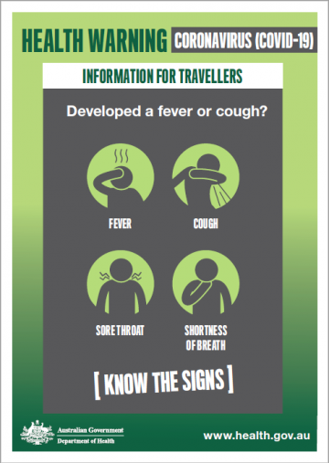
- stay home if you are sick.
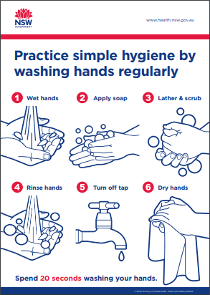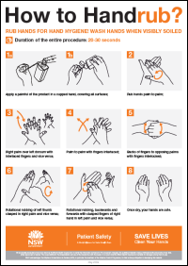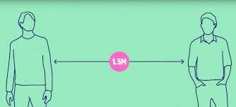
Call the National Coronavirus Health Information line 1800 020 080

For more information
Visit the NSW Health Website​.
Page Updated: Thursday 5 March 2020 Contact page owner: Health Protection NSW

