Return to Full Rally Day Risk Assessment
In line with the AIS National Principals for Sport and Recreation Activities and Office of Sport NSW Recovery Group framework Clubs and Zone may now return to full rally day and competition in line with the most recent NSW Public Health Orders dated 7th July 2020.
The Public Health Order (COVID-19 Border Control) was updated on 7 July 2020 and as a result of this, any person who has been in Victoria within the 14 days prior to that date are now classified as an ‘affected person’.

Under the legislation, any ‘affected person’ must reside at their usual place of residence or other suitable place of accommodation until a period of 14 days has elapsed since the person entered NSW. During these 14 days the person must not leave the residence unless it is for reasons identified in section 3a of the attached Public Health Order.

PCA NSW need to remain vigilant as we do not want our sport and any club or area to become the next COVID-19 cluster.
Pony Clubs and Zones must complete:
- A Risk Assessment for all activities and events
- Covid Safety Plan
- Appoint a Covid Safety Coordinator
- Complete resumption of sport checklist
- Ensure records are kept of everyone who attends pony club activities and events (recommend the use of Covid Self-declaration form)
Full details on the Public Health Orders and restrictions can be found:
nsw.gov.au/covid-19/what-you-can-and-cant-do-under-rules
Please be aware that these are valid as of the 7th July 2020 and may change therefore you will need to continue to monitor the situation via NSW Premier media releases, Public Health Orders, Office of Sport, or PCA NSW website.
MPC Risk Management Team | MPC Rally Day Team
Club Senior Instructor – Heather Coutts  President and Safety Officer – Rob McLachlan  Covid Safety Coordinator, Secretary and MPIO – Cait Greenup | Shona Davis, Gayle Herbert, Ingrid Venables
Signed: Shauna Haipola (ZCI), Rob McLachlan, Cait Greenup Dated: 18th July 2020
Please see Risk Matrix at the end of this document to determine the importance of each activity.
Full rally day risk assessment for 19th July 2020
Risk | Risk Rating | Control / Actions | Person Responsible
Outbreak of Covid-19 | 2 | Appointing a Covid Safety Coordinator to ensure that everyone attending complies with the Covid Safe guidelines provided under the Public Health Orders, the club to send copies of the following to the PCA NSW State Office:  - Venue Risk Assessment,  - Covid Safety Plan and  - Details of nominated Covid Safety Coordinator | Rally Day Team
Attendance of ‘affected persons’ under the NSW Public Health Orders 7 July 2020 | 1 | Under the legislation, any ‘affected person’ must reside at their usual place of residence or other suitable place of accommodation until a period of 14 days has elapsed since the person entered NSW. During these 14 days the person must not leave the residence unless it is for reasons identified in section 3a of the attached Public Health Order | Self-monitoring ‘affected persons’ must self-isolate  Rally Day Team  Covid Safety Coordinator
Attendees to complete Covid-19 declaration form as part of the RSVP which states that they are well and have not had contact with anyone with COVID-19 | 1 | If rider and/or family members have been to Covid-19 affected areas, or been in contact with someone who has Covid-19 or shows symptoms of Covid-19 they may not attend and need to self-isolate for 14 days and unable to attend pony club until signed off by Doctor with a negative Covid-19 test result.  All participants and support person/s attending grounds MUST complete Covid-19 declaration form prior to attending. If participant and support person/s do not complete a form they must be asked to leave the grounds. | Self-monitoring and if necessary self-isolate– members must determine their own level of risk depending and their current health status
Contracting Covid-19 during travel to event – driving | 4 | Ensure that riders follow all guidelines produced by NSW Health on how to protect yourself – see NSW Health website and recommendations below. | Self-monitoring – members must determine their own level of risk depending and their current health status
Contracting Covid-19 – whilst at Pony Club | 4 | - PCA NSW have strict bio-security protocols in place for both riders and horses.  - Riders to follow all directions of Rally Day Team  - Rally Day Team will ensure that the venue has been cleaned prior to commencement maintained during the event  - Rally Day Team to provide washing facilities and/or 60% alcohol based hand sanitiser  - Rider and other attendees to regularly wash hands/use hand sanitiser and social distance as per NSW Health regulations  - Riders and other attendees to follow all guidelines produced by NSW Heath on how to protect yourself – see below  - Minimal equipment will be used and will be handled by dedicated support person(s) | - Covid Safety Coordinator  - Rally Day Team to oversee cleaning crews prior and during the event.  - Rally Day Team to monitor hand sanitiser if being used to ensure that there is enough on hand  - Self-monitoring – members must determine their own level of risk depending and their current health status
If rider has concerns of possible contraction of Covid-19 | 2 | Follow NSW Health update on how the virus is spread and how long does Covid-19 last on surfaces - riders should follow all directions of Rally Day Teams and follow all guidelines produced by NSW Heath on how to protect yourself – see recommendations below. | Self-monitoring – members must determine their own level of risk depending and their current health status
Gear Check – no contact to be made | 2 | - No contact by Gear Check Steward to rider or their equipment during Gear Check  - Rider (if old enough) or parent/responsible person to be on hand (one per rider only) during Gear Check to make any adjustments to gear as requested by Gear Check Steward | - Covid Safety Coordinator  - Gear Check Steward  - Rider  - Parent/responsible adult
Contact between Instructors and rider – no contact to be made | 2 | - No contact by Instructor to rider or their horse during Instructions of any kind.  - Parent and/or responsible adult to be on hand (one per rider only) to aid if needed.  - Instructors may work with more than one group, however, they must sanitise their hands between groups and follow physical distancing rules. | - Covid Safety Coordinator  - Instructor  - Rally Day Team  - Parent/responsible adult
Contact between riders whilst mounted – no contact to be made | 2 | - Riders to continue to be distanced accordingly to minimise the risk of contact from rider to rider whilst mounted.  - Riders to be advised that contact to be avoided both while mounted and unmounted  - Groups of riders under instruction should not exceed reasonable instructor to rider guidelines at any time. MPC guidelines are a max of 10 riders per group.  - While the number of people attending is no longer limited Rally Day Teams must continue to ensure rider, spectator and volunteers’ safety and always continue to maintain distancing and good hygiene practices. | - Covid Safety Coordinator  - Instructor  - Rally Day Team  - Parent/responsible adult
Contact between Officials, judges, gear checker, stewards, and other personnel during competition | 2 | - Always maintain social distancing  - Follow good hygiene practices  - No contact between riders and officials  - Clean any shared equipment before, during and after each event  - Riders to provide their own gear, uniform etc. and not share or borrow someone else’s  - Where possible limit activities that depend on multiple use of gear or equipment and/or provide extra cleaning to minimise the risk of cross contamination | - Rally Day Team  - Covid Safety Coordinator  - Volunteers  - Riders  - Parents/supports
Response to fall of a rider | 3 | - The Rally Day Team should appoint a dedicated First Aid person for the event  - The only people who may contact or respond to a fallen rider is the dedicated First Aid person or their parent/responsible adult  - All normal procedures regarding First Aid to be taken  - First Aider to always wear all appropriate PPE including mask and gloves  - Dedicated First Aider or another person authorised to act on their behalf should call an ambulance if necessary – please ensure that only one person calls, and that person has venue and patient details and information needed to help guide the ambulance to the venue | - Covid Safety Coordinator  - Rally Day Team  - Dedicated First Aider  - Parent/responsible adult
Parking, catering, use of facilities by people attending Rally Day | 2 | - Communicate with members to advise expectations at rally/practice days  - Submitting self-screening forms  - Follow directions  - Determine who will speak to people showing symptoms of COVID-19  - Provision of PPE as appropriate on hand for members to use.  - Signage throughout the venue on COVID-19 symptoms, good hygiene and social distancing 1.5m  - Information about spacing between vehicles to be provided with club event plan  - No canteen facilities - riders to bring own food and drink with no sharing of food or drink between riders or others on the grounds  - Riders need to be ready to ride other than gear check so that they are not on the grounds longer than needed for scheduling purposes  - No overnight stays  - All persons on grounds to adhere to strict social distancing guidelines 1.5m between people  - All persons on grounds to follow strict hygiene  - All participants to be checked off the attendance list before entering the assembly/gear check area.  - Sanitiser to be provided at attendance check desk  - Attendees are responsible for their own hygiene using Council facilities such as toilets  - Hand sanitiser will be provided at attendance check desk, and with each riding group. | - Covid Safety Coordinator  - Instructor  - Rally Day Team  - Parent/responsible adult
Instructor travel and accommodation | 2 | - Where possible local Instructors to be used to limit travel and associated risks  - Where possible local Instructors to be used to limit accommodation needs, if accommodation needed ensure that accommodation is withing restrictions | - Covid Safety Coordinator  - Instructor  - Rally Day Team
Venue Specific concerns – please list details here as necessary |  | List items that are specific to your club here/use as many pages as necessary  - MARC will also be using the grounds. MPC members to park floats separate from the MARC floats, further away from the yards. Yards are not be used. Entry to the Moonshed paddock is through the gate closest to the arena NOT the gates next to the yards. The water point near the arena to to be used NOT the water points at the yards. | - Covid Safety Coordinator  - Rally Day Team

Protect yourself
The best way to protect yourself from COVID-19 is the same way you would protect yourself from catching flu or other respiratory illness:
- wash your hands for at least 20 seconds with soap and water or use an alcohol-based sanitiser with at least 60% alcohol.
- cover your sneeze or cough with your elbow or with tissue.
- avoid close contact with people who are ill
- avoid touching your eyes, nose and mouth
- stay home if you are sick.
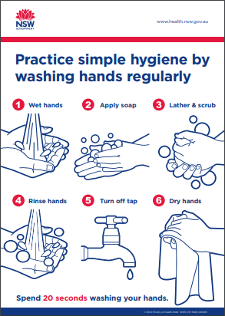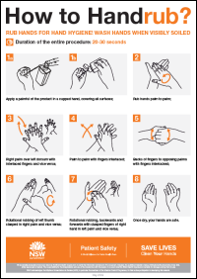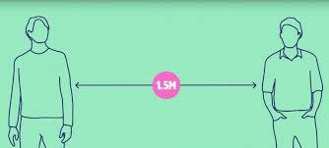
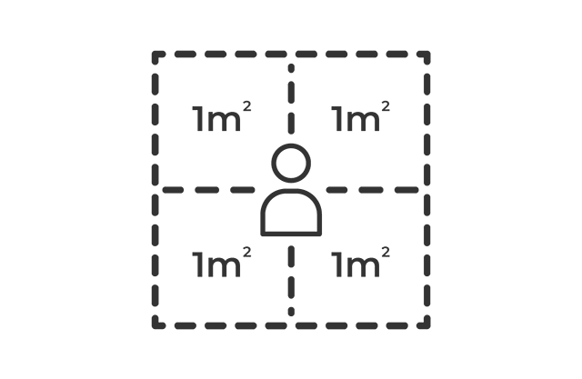
The 4 square metre rule helps to determine the maximum number of people allowed on the premises or attending an event. It does not determine the distance between people.
Physical distancing means reducing the close physical contact we have with one another and staying 1.5 metres away from people we don't live with.
Allow 1 person per 4 square metres
Call the National Coronavirus Health Information line 1800 020 080
For more information visit the NSW Health Website​.
How severe could it hurt someone or how ill it could make someone | 2. How likely is it to be that bad?
 | Very Likely Could Happen Anytime | Likely  Could happen sometime | Unlikely  Could happen but very rarely | Very Unlikely Could happen but probably never  will
Kill or cause permanent  disability or ill health | 1 | 1 | 2 | 3
Long term illness or serious injury | 1 | 2 | 3 | 4
Medical Attention and several days off  work | 2 | 3 | 4 | 5
First aid needed | 3 | 4 | 5 | 6

LEGEND
The risk rating number indicates the priority of the risk:
1 - Top Priority: Do something immediately
6 - Low Priority: Do something when possible

CONTROL PROCEDURE
The control procedure is a list of control measures, in order of priority, which can be used to eliminate or minimize exposure to hazards.
- ELIMINATE – avoid risk by removing the hazard completely
- SUBSTITUTE – use less hazardous procedure/substances equipment/process
- ISOLATE – separate the process form people by the use of barriers/enclosure or distance
- ENGINEERING CONTROL – mechanical/physical changes to equipment /materials/process
- ADMINISTRATIVE CONTROL - change procedures to reduce/eliminate exposure to hazard
- PERSONAL PROTECTIVE EQUIPMENT – supply where required

DEFINITIONS
- CONTROL PROCEDURE – a series of control options ranked towards greatest and most efficient management of hazard
- HAZARD – something with the potential to cause injury or illness
- RISK - the probability of a hazard resulting in an injury or illness together with the seriousness of the injury

